# Pets

You need to add 20 things to this document. (Make sure to number them just as I did in the example.) It may be helpful to copy and paste this list and then fill it in as you go along. All image names must start with your location, e.g yellowstone_sunset.jpg unless you are using a link from the internet.

[Link to Pet Files](https://drive.google.com/drive/folders/1nhZB2OqrJRNrIEnGaLqT-YyQ_IX5Owve)

## Juno

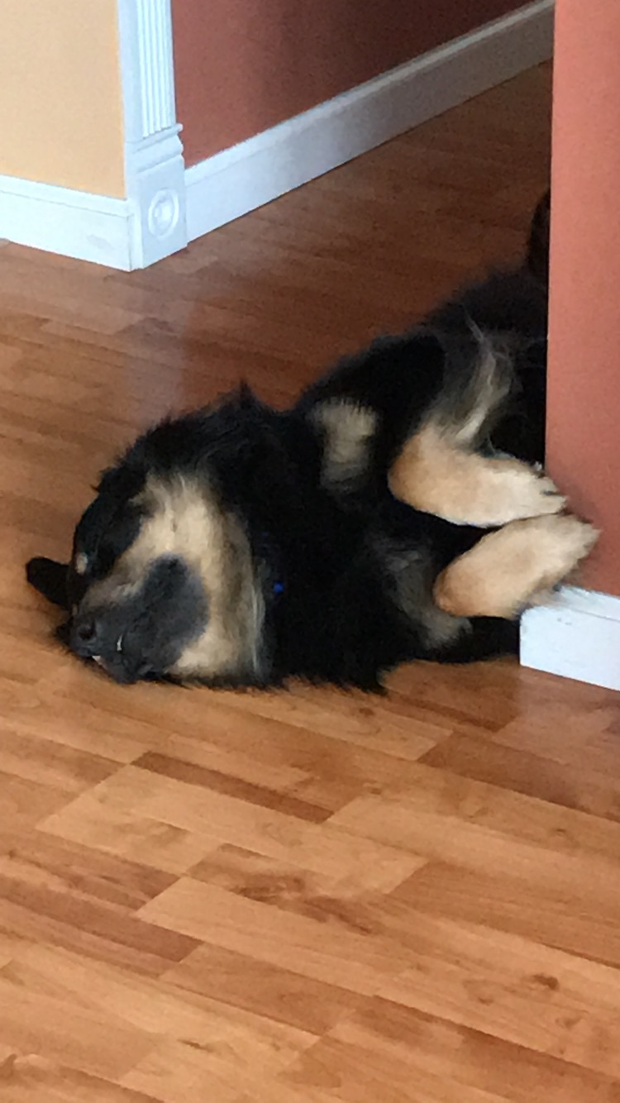

1. classic_juno.JPG
2. Black and brown dog asleep on his side
3. No one knows exactly what breed Juno is, but that makes him all the more special. He was adopted before he was one year old; despite this and his German shepherd-esque looks, he stayed close to the same size, hovering around 50 lbs into adulthood. At the weathered age of ten years old, Juno is dealing with hip problems, but manages to stay in good spirits.
4. One of Juno’s favorite pastimes is finding the dirtiest puddle within a one-mile radius and making sure every inch of him makes contact with said puddle. If rolling around in dirt was an Olympic sport, Juno would have been the one that facilitated its inclusion into the Olympics.
5. **Photo Gallery – (Just write Photo Gallery)**
6. juno_pup.JPG
7. A young black and brown dog with his tongue hanging out
8. juno_laying.JPG
9. A black and brown dog laying on a rug
10. juno_laying_2.JPG
11. A black and brown dog laying on a wood floor
12. juno_profile.JPG
13. A profile perspective of a black and brown dog from shoulders up
14. **Likes – (Just write Likes)**
15. Human food
16. Head pats
17. Sleeping
18. Artem Saakov